UNIT 2
Project management techniques

2.1 Introduction to project development techniques.
The world of project management is vast. It covers many industries and requires a range of skills. But the common thread tying this diverse discipline together are the techniques that project managers use to get the job done. Project management techniques make planning and managing projects easier and more effective. They can be applied to any project, regardless of the field or industry. And used in with project management software, as they help save time and reduce costs.
Project management techniques are strategies that help a team optimize its workflow and ensure success, whether that be reduced waste, increased profits or improved customer satisfaction. Project managers may use various techniques to organize, schedule and manage their teams throughout each project phase, including:
- Initiation
- Planning
- Execution
- Conclusion

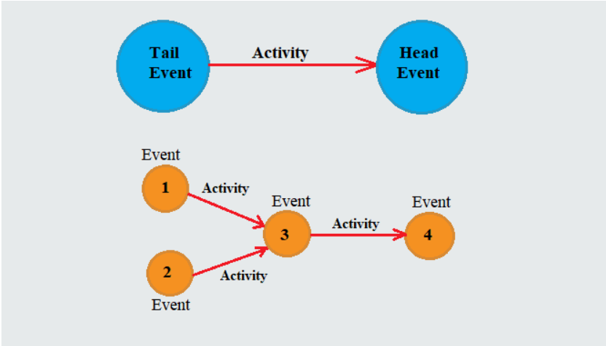

2.2 PERT introduction and its implementation.
Program Evaluation Review Technique (PERT) is a project management planning tool used to display graphical representation of a project’s timeline and to calculate the amount of time it will take to realistically finish a project. PERT charts are used to plan tasks within a project — making it easier to schedule and coordinate team members.
PERT charts were created in the 1950s to manage the creation of weapons and defense projects for the US Navy. While PERT was being introduced in the Navy, the private sector simultaneously gave rise to a similar method called critical path. PERT is similar to critical path, they are both used to visualize the timeline and the work that must be done for a project. PERT is calculated backward from a fixed end date since contractor deadlines typically cannot be moved.
However with PERT, you create three different time estimates for the project:
- The shortest possible amount of time each task will take.
- The most probable amount of time.
- The longest amount of time tasks might take if things don't go as planned.

Advantages of PERT
Here are several benefits of using PERT in project management:
- It helps maximize the use of resources.
- It makes project planning more manageable.
- It’s useful even if there is little or no previous schedule data.
- It enables project managers to better estimate or determine a more definite completion date.
Disadvantages of PERT
Like any other method, PERT comes with its share of limitations:
- In complex projects, many find PERT hard to interpret, so they may also use a Gantt Chart, another popular method for project management.
- It can be tedious to update, modify, and maintain the PERT diagram.
- It entails a subjective time analysis of activities and, for those who are less experienced or are biased, this may affect the project’s schedule.

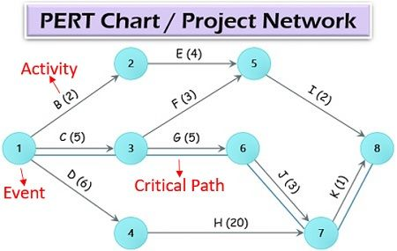
Example: PERT chart
Element in PERT network diagram:
- Event: An event can be understood as the node at which an activity starts or ends.
- Activity: It refers to the actions taken or the task to be accomplished as a part of the whole project execution process. In brackets, the estimated time required for performing the particular task is mentioned. It can be in hours, days, weeks or months.
- Critical Path: The path which passes through all those essential activities which are carried out in a sequence and links the first event to the last event.
Example:
Activity | Estimated duration (weeks)
Activity | Optimistic (to) | Most likely (tm) | Pessimistic (tp)
1-2 | 1 | 7 | 13
1-6 | 2 | 5 | 14
2-3 | 2 | 14 | 26
2-4 | 2 | 5 | 8
3-5 | 7 | 10 | 19
4-5 | 5 | 5 | 17
6-7 | 5 | 8 | 29
5-8 | 3 | 3 | 9
7-8 | 8 | 17 | 32
- Draw the project network.
- Find the expected duration and variance of each activity.
- Calculate the earliest and late occurrence for each event.
- Calculate expected project length.
- Calculate the variance and standard deviation of project length.
- Find the probability of the project completing in 40 days.
Here,
Optimistic time = t_{o} or a
Most likely time= t_{m} or m
Pessimistic time=t_{p} or b
For these three estimate, we have to calculate the expected time of an activity.
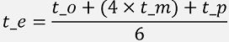
Variance of an activity is given by,
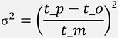
Task 1 and Task 3:
Network Diagram
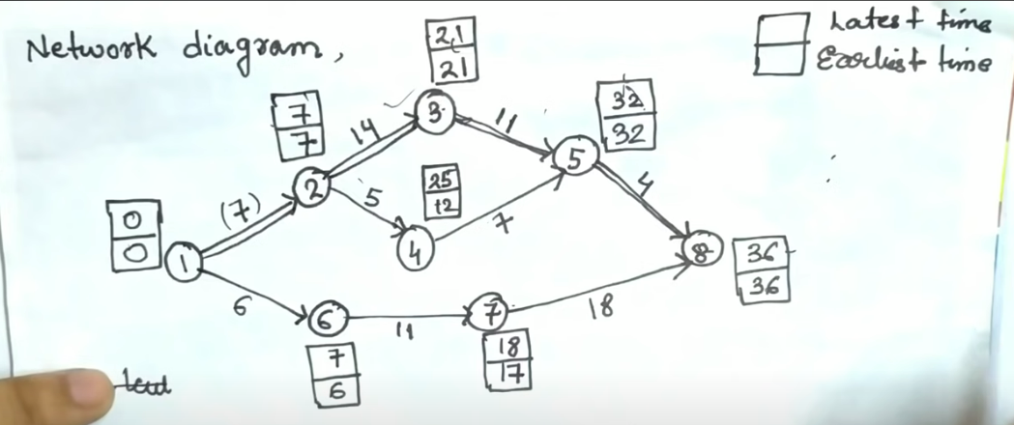

Task 2:
Activity | Estimated duration (weeks) |  |  | T_{e}= (t_{o}+4t_{m}+t_{p}) / 6 | σ²= (t_{p}-t_{o}/6)²
Activity | Optimistic (t_{o}) | Most likely (t_{m}) | Pessimistic (t_{p}) | T_{e}= (t_{o}+4t_{m}+t_{p}) / 6 | σ²= (t_{p}-t_{o}/6)²
1-2 | 1 | 7 | 13 | 7 | 4
1-6 | 2 | 5 | 14 | 6 | 4
2-3 | 2 | 14 | 26 | 14 | 16
2-4 | 2 | 5 | 8 | 5 | 1
3-5 | 7 | 10 | 19 | 11 | 4
4-5 | 5 | 5 | 17 | 7 | 4
6-7 | 5 | 8 | 29 | 11 | 16
5-8 | 3 | 3 | 9 | 4 | 1
7-8 | 8 | 17 | 32 | 18 | 16
Task 4:
In this project the critical path is 12358.
The total duration of this project =7+14+11+4 = 36 days.
Task 5
Project length variance= sum of variance of activities(σ²) from critical path
=4+16+4+1 = 25
Project length standard deviation (σ)= 5
Task 6:
D= (T_{s}-t_{e}) / σ
where Ts is the schedule time to complete the project,
T_{e}= Normal expected project length,
σ= standard deviation of the project length.
The probability that the project will be completed in 40 days is given by P(Z ≤ D).
D= (T_{s}-t_{e}) / σ = (40-36) / 5 = 0.8
P(Z≤0.8) = 0.7881 = 78.81 %
The probability that the project will be completed in 40 days is 78.81%.

2.3 CPM introduction and its implementation.
The critical path method (CPM) is a technique where you identify tasks that are necessary for project completion and determine scheduling flexibilities. A critical path in project management is the longest sequence of activities that must be finished on time in order for the entire project to be complete. Any delays in critical tasks will delay the rest of the project. CPM revolves around discovering the most important tasks in the project timeline, identifying task dependencies, and calculating task durations.
CPM was developed in the late 1950s as a method to resolve the issue of increased costs due to inefficient scheduling. Since then, CPM has become popular for planning projects and prioritizing tasks. It helps you break down complex projects into individual tasks and gain a better understanding of the project’s flexibility. CPM can provide valuable insight on how to plan projects, allocate resources, and schedule tasks. The essential technique for using CPM is to construct a model of the project that includes the following:
- A list of all tasks required to complete the project
- The dependencies between the tasks
- The estimate of time (duration) that each activity will take to complete.
With this information, you can determine the critical path by identifying the longest stretch of dependent activities and measuring them from start to finish.
Here are some reasons why you should use this method:
- Improves future planning: CPM can be used to compare expectations with actual progress. The data used from current projects can inform future project plans.
- Facilitates more effective resource management: CPM helps project managers prioritize tasks, giving them a better idea of how and where to deploy resources.
- Helps avoid bottlenecks: Bottlenecks in projects can result in lost valuable time. Plotting out project dependencies using a network diagram, will give you a better idea of which activities can and can’t run in parallel, allowing you to schedule accordingly.
Example of CPM:
ACTIVITY | PREDECESSOR | DURATION(MONTHS)
A | - | 5
B | A | 4
C | A | 5
D | B | 6
E | C | 3
F | D, E | 4

TASK:
- Construction of CPM network.
- Determine values of ES, EF, LS, LF, D and SL.
- Finding critical path and project completion time.
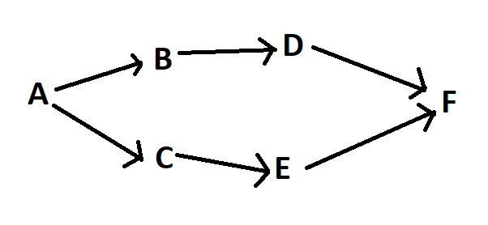
Task 1: Construction of CPM network
Task 2: Determining values.
ES |  | D | EF
N
LS | SL |  | LF
Here, ES= Earliest Start, EF= Earliest Finish, LS= latest Start, LF= latest Finish, D= Duration, SL= Slack time and N= Node time
0 |  | 5 | 5
A
0 | 0 |  | 5
5 |  | 4 | 9
B
5 | 0 |  | 9

9 |  | 6 | 15
D
9 | 0 |  | 15
5 |  | 5 | 10
C
7 | 2 |  | 12

10 |  | 3 | 13
E
12 | 2 |  | 15
15 |  | 4 | 19
F
15 | 0 |  | 19

Here, ES and EF is determined through forward pass and LS, SL and LF is determined through Backward pass.
Formula:
EF=ES+D
SL=LF-EF / LS-ES
LS=LF-D
NOTE: If there are multiple predecessors while performing forward pass, select the largest value and while performing backward pass select smallest value.
Slack=Delay=Float.
TASK 3:
Here, Critical path is determined where slack time is zero (0). So, the Critical path for this project is ABDF.
Duration of project= sum of duration(time) of critical nodes/ activities.
Total duration of project= 5+4+6+4 = 19 months
Therefore, the duration of project is 19 months.

What is Float(slack)?
Float, or slack, refers to the amount of flexibility of a given task. It indicates how much the task can be delayed without impacting subsequent tasks or the project end date. Finding the float is useful in gauging how much flexibility the project has. Float is a resource that should be used to cover project risks or unexpected issues that come up. Critical tasks have zero float, which means their dates are set. Tasks with positive float numbers belong in the non-critical path, meaning they may be delayed without affecting the project completion date. If you’re short on time or resources, non-critical tasks may be skipped.
Here’s a breakdown of the two types of floats:
Total float: This is the amount of time that an activity can be delayed from the early start date without delaying the project finish date or violating a schedule constraint. Total float = LS - ES or LF - EF
Free float: This refers to how long an activity can be delayed without impacting the following activity. There can only be free float when two or more activities share a common successor. On a network diagram, this is where activities converge. Free float = EF - ES – D (time duration)
NOTE: while calculation free float, if there is same successor (ending node) take the largest value for calculation.
Example 2:
A project schedule has the following characteristics.
Table 1:
Activity | 1-2 | 1-3 | 2-4 | 3-4 | 3-5 | 4-9 | 5-6 | 5-7 | 6-8 | 7-8 | 8-10 | 9-10
Time (days) | 4 | 1 | 1 | 1 | 6 | 5 | 4 | 8 | 1 | 2 | 5 | 7

- Construct Network diagram.
- Compute earliest event time and latest event time.
- Determine the critical path and total project duration.
- Compute total and free float for each activity.
Task 1 and Task 2:
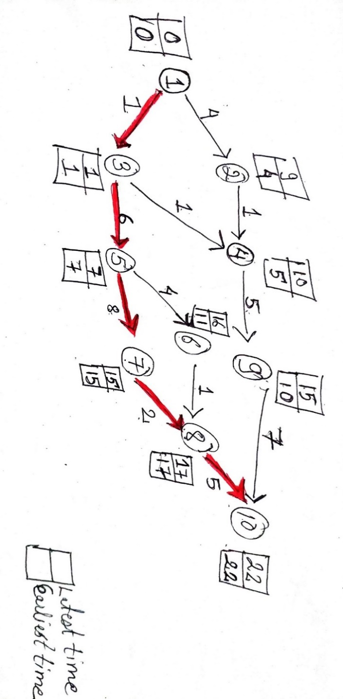

Following table give the information.

Table 2:
Activity | Time  (days) | Earliest |  | Latest |  | Total  Float (SL) | Free  Float (FF)
Activity | Time  (days) | Start (ES) | Finish (EF) | Start (LS) | Finish (LF) | Total  Float (SL) | Free  Float (FF)
1-2 | 4 | 0 | 4 | 5 | 9 | 5 | 0
1-3 | 1 | 0 | 1 | 0 | 1 | 0 | 0
2-4 | 1 | 4 | 5 | 9 | 10 | 5 | 0
3-4 | 1 | 1 | 2 | 9 | 10 | 8 | 3 (Here EF=5 because activity 2-4, 3-4 has same ending node)
3-5 | 6 | 1 | 7 | 1 | 7 | 0 | 0
4-9 | 5 | 5 | 10 | 10 | 15 | 5 | 0
5-6 | 4 | 7 | 11 | 12 | 16 | 5 | 0
5-7 | 8 | 7 | 15 | 7 | 15 | 0 | 0
6-8 | 1 | 11 | 12 | 16 | 17 | 5 | 5 (Here EF=17 because activity 6-8, 7-8 has same ending node)
7-8 | 2 | 15 | 17 | 15 | 17 | 0 | 0
8-10 | 5 | 17 | 22 | 17 | 22 | 0 | 0
9-10 | 7 | 10 | 17 | 15 | 22 | 5 | 5(Here EF=22 because activity 8-10, 9-10 has same ending node)

ES |  | D | EF
N
LS | SL |  | LF
Here, ES= Earliest Start, EF= Earliest Finish, LS= latest Start, LF= latest Finish, D= Duration, SL= Slack time and N= Node time
0 |  | 4 | 4
1-2
5 | 5 |  | 9
0 |  | 1 | 1
1-3
0 | 0 |  | 1

1 |  | 1 | 2
3-4
9 | 8 |  | 10

4 |  | 1 | 5
2-4
9 | 5 |  | 10
5 |  | 5 | 10
4-9
10 | 5 |  | 15

1 |  | 6 | 7
3-5
1 | 0 |  | 7

7 |  | 4 | 11
5-6
12 | 5 |  | 16
7 |  | 8 | 15
5-7
7 | 0 |  | 15

11 |  | 1 | 12
6-8
16 | 5 |  | 17
15 |  | 2 | 17
7-8
15 | 0 |  | 17

17 |  | 5 | 22
8-10
17 | 0 |  | 22
10 |  | 7 | 17
9-10
15 | 5 |  | 22

Here, ES and EF is determined through forward pass and LS, SL and LF is determined through Backward pass.
Formula:
EF=ES+D
SL=LF-EF / LS-ES
LS=LF-D
TASK 3:
Here, Critical path is determined where slack time or Total float is zero (0). So, the Critical path for this project is 1357810.
Duration of project= sum of duration(time) of critical nodes/ activities.
Total duration of project= 1+6+8+2+5
Therefore, the duration of project is 22 days.
Task 4
Total float = LS - ES or LF - EF
Free float = EF – ES- D (time duration)
NOTE: while calculation free float, if there is same successor (ending node) take the largest EF value for calculation.
All the required data is mentioned in above Table 2.

2.4 Implementation of project management techniques in real world
Question 1 (PERT):
Activity | Predecessors | Duration (weeks)
Activity | Predecessors | To | Tm | Tp
A | - | 5 | 6 | 7
B | - | 1 | 3 | 5
C | - | 1 | 4 | 7
D | A | 1 | 2 | 3
E | B | 1 | 2 | 9
F | C | 1 | 5 | 9
G | C | 2 | 2 | 8
H | E, F | 4 | 4 | 10
I | D | 2 | 5 | 8
J | H, G | 2 | 2 | 8
- Construct the Project Network.
- Find the expected duration and variance of each activity.
- Find the critical path and expected project completion time.
- What is the probability of completing the project on or before 22 weeks?

